Citizen Grievance Redressal & Escalation Management System (CGR-EMS)

Submitted To:
Ms. Banisha Sharma
Submitted By:

Hunar Kaur 1024031082
Bismanjot Singh 1024030558
Jasmeh Singh Sodhi 1024030396
THAPAR INSTITUTE OF ENGINEERING AND TECHNOLOGY,
(A DEEMED TO BE UNIVERSITY), PATIALA, PUNJAB
INDIA
Session-Year (2026)

1 INTRODUCTION
The Citizen Grievance Redressal & Escalation Management System (CGRMS) is a comprehensive database-driven project designed to efficiently manage, track, and resolve grievances submitted by citizens related to public services. Built using SQL and PL/SQL and structured around core relational database principles, this project integrates multiple interconnected entities such as citizens, grievances, departments, officers, escalations, and feedback into a unified backend system.By automating critical processes such as grievance registration, assignment, escalation, resolution tracking, and feedback collection, the system provides a robust framework for transparent, reliable, and efficient grievance management. The use of a centralized database ensures structured data storage, faster retrieval, and consistent decision-making.
The project employs a well-defined relational schema with carefully designed tables representing entities such as Citizen, Grievance, Department, Officer, Escalation, and Feedback. These tables are interlinked using primary keys and foreign keys to maintain data integrity, enforce relationships, and minimize redundancy. The database is normalized up to Third Normal Form (3NF), ensuring efficient data organization and consistency.The system is scalable and adaptable, making it suitable for deployment across various government bodies or public service organizations with differing requirements. By replacing manual or file-based grievance handling mechanisms, the proposed system significantly improves efficiency, accountability, and transparency.
The Citizen Grievance Redressal & Escalation Management System benefits multiple stakeholders as follows:
- Ø Citizens can register grievances, track their status, and provide feedback after resolution.
Ø Officers can manage assigned grievances, update resolution status, and handle escalations efficiently.
Ø Administrators and Departments can monitor grievance trends, oversee performance, and generate meaningful reports for decision-making.
Overall, this project demonstrates the effective use of SQL and PL/SQL for backend database implementation, highlighting the importance of DBMS concepts in solving real-world administrative problems.

2 BACKGROUND
Managing citizen grievances has become increasingly complex due to the growing population, expansion of public services, and rising expectations for transparency and accountability. Traditional manual or semi-digital methods of handling grievances—such as paper records, emails, or disconnected systems—are slow, error-prone, and inefficient. These methods often lead to misplaced complaints, delayed resolutions, lack of proper escalation, and minimal feedback tracking.With the increasing volume of grievances across multiple departments, government bodies and public service organizations face significant challenges in maintaining accurate records, ensuring timely resolution, and providing citizens with a reliable grievance redressal mechanism. The absence of a centralized system makes it difficult to monitor grievance status, evaluate departmental performance, and enforce accountability.
The Citizen Grievance Redressal & Escalation Management System (CGRMS) is developed to address these challenges by introducing a centralized, database-driven solution that integrates all aspects of grievance handling into a single platform. Built using SQL and PL/SQL, the system provides several key benefits:
- Ø Data Integrity: Ensures accurate and consistent grievance data through the use of primary keys (PK), foreign keys (FK), and integrity constraints.
Ø Automation: Replaces manual grievance tracking with automated processes such as status updates, escalation handling, and validation through triggers and procedures.
Ø Scalability: Designed to handle an increasing number of grievances, departments, and users without affecting system performance.
Ø Efficiency: Enables faster data retrieval and reporting, allowing administrators to make informed decisions and improve service delivery.
By integrating grievance registration, assignment, escalation, resolution, and feedback collection into a unified database system, the proposed solution simplifies operations for departments and enhances the experience for citizens. It also ensures that public service organizations are well-equipped to handle future growth while maintaining efficiency, transparency, and trust in the grievance redressal process.

3 PROBLEM STATEMENT
Public service organizations often receive a large number of grievances from citizens related to essential services such as water supply, electricity, sanitation, and infrastructure. Managing these grievances using traditional manual methods or unstructured digital records presents a significant real-world problem. Complaints are frequently recorded on paper, emails, or isolated systems, making it difficult to organize, track, and resolve them efficiently.
The existing grievance handling mechanisms suffer from several limitations. Manual systems are time-consuming, error-prone, and lack proper data validation. There is no structured way to link citizens, grievances, departments, and officers, which leads to poor accountability and delayed responses. Additionally, the absence of an automated escalation mechanism means unresolved grievances may remain unattended for long periods. Data redundancy, inconsistency, and difficulty in generating reports further reduce the effectiveness of the current system.
To overcome these challenges, there is a strong need for a database-driven grievance management system that can store, process, and retrieve grievance information in a structured manner. The use of a Database Management System (DBMS) enables centralized data storage, enforcement of relationships using primary and foreign keys, and maintenance of data integrity through constraints. SQL and PL/SQL can be effectively used to automate grievance registration, status tracking, escalation, and feedback handling.
Thus, the scope of database usage in solving this problem lies in designing a normalized relational schema, implementing efficient SQL queries, and using PL/SQL components to automate critical operations. This approach ensures faster grievance resolution, improved transparency, better decision-making, and a reliable grievance redressal mechanism for both citizens and administrators.

4 OBJECTIVES OF THE PROJECT
The primary objectives of the Citizen Grievance Redressal & Escalation Management System are focused on designing and implementing a robust backend database solution that efficiently manages grievance-related data while ensuring integrity, scalability, and automation. The key objectives of the project are as follows:
- To design a database using E–R data modeling
  - The first objective of the project is to analyze the real-world grievance redressal process and represent it using an Entity–Relationship (ER) model. Entities such as Citizen, Grievance, Department, Officer, Escalation, and Feedback are identified along with their attributes and relationships. The ER model helps in visualizing how data is structured and how different entities interact within the system.
- To convert the ER model into relational tables
  - Another important objective is to convert the ER diagram into a relational schema by mapping each entity to a table. Appropriate primary keys and foreign keys are assigned to maintain relationships such as one-to-many and one-to-one. This conversion ensures that the conceptual design is accurately implemented in the relational database.
- To apply normalization techniques (up to 3NF/BCNF)
  - The project aims to apply normalization techniques to eliminate data redundancy and improve data consistency. By identifying functional dependencies and applying normalization up to Third Normal Form (3NF), the database design ensures that all non-key attributes depend only on the primary key, resulting in an efficient and well-structured schema.
- To implement the database using SQL
  - A major objective of the project is to implement the designed database using SQL. This includes using DDL commandsto create tables, DML commands to insert and update data, and SELECT queries involving joins, aggregate functions, and subqueries to retrieve meaningful information related to grievances, departments, and officers.
- To use PL/SQL constructs for automation
  - The project also aims to utilize PL/SQL constructs such as stored procedures, functions, triggers, and cursors to automate backend operations. Procedures are used for structured data insertion, triggers are implemented for automatic escalation and validation, functions support reusable logic, and cursors enable controlled row-by-row processing of data.
- To ensure data consistency using constraints and transactions
  - The final objective is to ensure data consistency, integrity, and reliability by enforcing constraints such as primary keys, foreign keys, UNIQUE, and CHECK constraints. Transaction management using COMMIT and ROLLBACK ensures that database operations follow ACID properties, maintaining a stable and reliable grievance management system.

5 SCOPE OF THE PROJECT
The scope of the Citizen Grievance Redressal & Escalation Management System is primarily focused on the backend database design and implementation using SQL and PL/SQL. The project aims to provide a structured and efficient mechanism for storing, processing, and retrieving grievance-related data while ensuring data integrity, consistency, and automation.

Functional Boundaries of the System

The system is limited to managing grievance-related operations such as registration, assignment, status tracking, escalation, resolution, and feedback collection. It does not include frontend development, user interface design, or web/mobile integration. All functionalities are implemented at the database level using SQL and PL/SQL, ensuring that the backend logic is robust and independent of any presentation layer.

Types of Users Involved

The system supports different categories of users based on their roles:
- Citizens (Users): Responsible for registering grievances, tracking grievance status, and providing feedback after resolution.
- Officers (Staff): Responsible for handling assigned grievances, updating status, and resolving issues within their departments.
- Administrators / Departments (Admin): Responsible for managing departments and officers, monitoring grievance progress, handling escalations, and generating reports.
- User roles are conceptually defined to support role-based operations, although authentication and access control are outside the scope of this backend-focused project.

Modules Covered (Backend Focus)

- The project covers the following backend modules:
- Citizen Management Module: Stores and manages citizen-related data.
- Grievance Management Module: Handles grievance registration, status updates, and assignment.
- Department and Officer Management Module: Maintains department and officer details and their relationships.
- Escalation Module: Automatically records and manages escalated grievances using triggers.
- Feedback Module: Collects and stores feedback after grievance resolution.
- Reporting and Query Module: Supports SQL queries for grievance tracking, departmental analysis, and performance evaluation.

6 PROPOSED SYSTEM DESCRIPTION
The proposed Citizen Grievance Redressal & Escalation Management System is a centralized, database-driven backend system designed to efficiently manage the complete lifecycle of citizen grievances. The system is implemented using SQL and PL/SQL and follows core relational database design principles to ensure structured data storage, reliable processing, and effective grievance tracking.

Overall Working of the Proposed Database System
In the proposed system, all grievance-related information is stored in a centralized relational database. Citizens register grievances, which are recorded in the database along with relevant details such as department, assigned officer, status, and submission date. Each grievance is uniquely identified and linked to the corresponding citizen and department through foreign keys.
Officers update grievance status as the issue is processed and resolved. If a grievance is not resolved within the required time or requires higher authority intervention, the system supports escalation through automated database triggers. Once a grievance is resolved, citizens can submit feedback, which is stored and linked to the grievance for performance evaluation and analysis.
All operations are handled at the backend level using SQL queries and PL/SQL programs, ensuring consistency and automation without dependence on a user interface.

Key Features and Functionalities
The proposed system offers several important backend features:
- Centralized Data Management: All grievance-related data is stored in a single database, eliminating data duplication and fragmentation.
- Automated Grievance Tracking: Grievance status is continuously updated and can be easily tracked using SQL queries.
- Escalation Handling: Automated escalation mechanisms are implemented using PL/SQL triggers to ensure timely resolution.
- Feedback Collection: Citizens can provide feedback after grievance resolution, enabling performance monitoring.
- Efficient Data Retrieval: SQL queries using joins, aggregate functions, and grouping allow efficient reporting and analysis.
- Scalability: The database design supports the addition of new departments, officers, and grievances without structural changes.

Improvement in Efficiency, Consistency, and Data Integrity
The proposed system significantly improves operational efficiency by replacing manual grievance handling with automated database operations. Data consistency is ensured through normalization, primary keys, and foreign keys, which maintain correct relationships between tables.Data integrity is enforced using constraints such as UNIQUE and CHECK constraints, as well as transaction management commands like COMMIT and ROLLBACK. The use of PL/SQL further enhances reliability by automating critical operations and validating business rules.
Overall, the proposed system provides a reliable, scalable, and transparent backend solution that enhances grievance redressal efficiency while maintaining high standards of data consistency and integrity.

7 DATABASE DESIGN
Database design is a crucial phase of the project as it defines how data is structured, stored, and related within the system. In the Citizen Grievance Redressal & Escalation Management System, database design is carried out using a systematic approach that begins with conceptual modeling and is followed by logical schema design. The design ensures data integrity, minimizes redundancy, and supports efficient grievance management operations.

7.1 Entity–Relationship (ER) Diagram
The Entity–Relationship (ER) diagram represents the conceptual design of the database and provides a graphical view of the system’s data requirements. It identifies the key entities involved in grievance redressal, their attributes, and the relationships among them. The ER diagram serves as the foundation for converting the conceptual model into a relational database.

Identification of Entities
The main entities identified in the system are:
- Citizen – Represents individuals who register grievances.
- Grievance – Represents complaints submitted by citizens.
- Department – Represents government departments responsible for handling grievances.
- Officer – Represents officials assigned to resolve grievances.
- Escalation – Represents grievances forwarded to higher authorities.
- Feedback – Represents feedback provided by citizens after grievance resolution.
Each entity corresponds to a real-world object involved in the grievance redressal process.

Identification of Attributes
Each entity consists of a set of attributes that describe its properties:
- Citizen includes attributes such as Citizen_ID, Name, Email, Phone, and Address.
- Grievance includes attributes such as Grievance_ID, Title, Description, Status, and Created_Date.
- Department includes attributes such as Department_ID and Department_Name.
- Officer includes attributes such as Officer_ID, Name, Email, and Department_ID.
- Escalation includes attributes such as Escalation_ID, Escalation_Date, and Reason.
- Feedback includes attributes such as Feedback_ID, Rating, and Comments.
Each entity contains a primary key that uniquely identifies records.

Identification of Relationships
The relationships among entities define how data is interconnected:
- A Citizen registers a Grievance.
- A Department handles multiple Grievances.
- An Officer resolves Grievances assigned to them.
- A Grievance may be escalated, resulting in escalation records.
- A Grievance receives Feedback after resolution.
These relationships ensure logical linkage between entities and reflect real-world grievance workflows.

Cardinality and Constraints
Cardinality constraints define the number of instances participating in relationships:
- One Citizen can register multiple Grievances (1:M).
- One Department can handle many Grievances (1:M).
- One Officer can resolve many Grievances (1:M).
- One Grievance can have multiple Escalations (1:M).
- One Grievance has only one Feedback (1:1).
Constraints such as total participation ensure that certain entities must participate in relationships, for example, every grievance must be registered by a citizen.
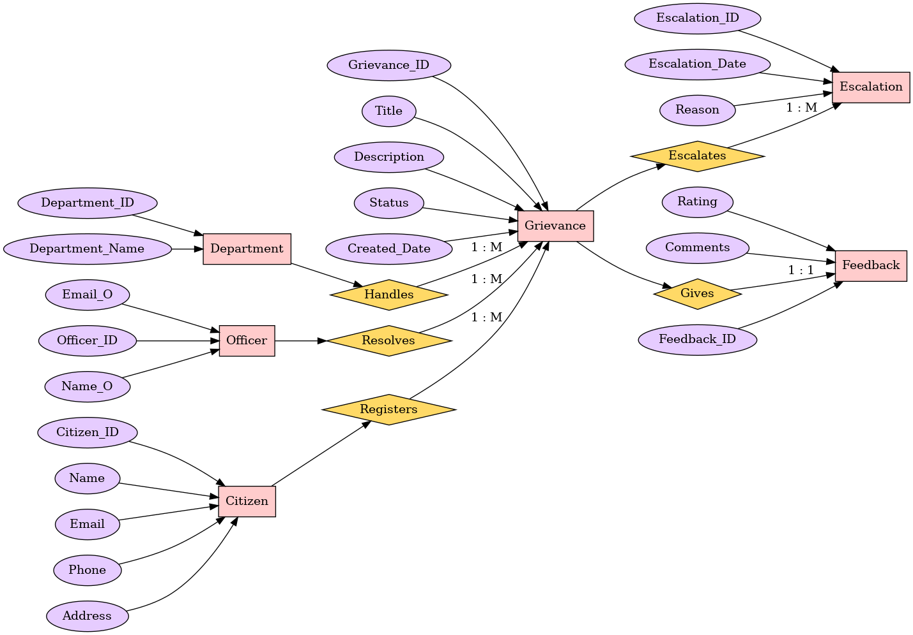

7.2 Relational Schema
After designing the ER diagram, the next step is to convert the conceptual model into a relational schema suitable for implementation using SQL. Each entity is mapped to a table, and relationships are implemented using foreign keys.

Conversion of ER Diagram into Tables
- Each entity in the ER diagram is converted into a relation (table).
- Attributes of entities become columns in the corresponding tables.
- Relationships are implemented by adding foreign keys to the appropriate tables.
This conversion ensures that the conceptual design is accurately represented in the relational database.

Primary Keys and Foreign Keys
- Primary keys (PK) are assigned to uniquely identify each record in a table.
- Foreign keys (FK) are used to establish relationships between tables.
For example:
- Citizen_ID acts as the primary key in the Citizen table.
- Grievance_ID acts as the primary key in the Grievance table.
- Citizen_ID in the Grievance table acts as a foreign key referencing the Citizen table.
These keys enforce referential integrity and prevent invalid data entries.

Table Relationships
The relational schema supports the following relationships:
- Citizen–Grievance: One-to-many relationship, implemented using Citizen_ID as a foreign key in the Grievance table.
- Department–Grievance: One-to-many relationship, linking grievances to departments.
- Officer–Grievance: One-to-many relationship, linking officers to grievances.
- Grievance–Escalation: One-to-many relationship, allowing multiple escalations for a grievance.
- Grievance–Feedback: One-to-one relationship, enforced using a UNIQUE constraint on Grievance_ID in the Feedback table.
The relational schema design ensures data consistency, minimal redundancy, and efficient query processing, making it suitable for backend implementation using SQL and PL/SQL.

8. NORMALIZATION
Normalization is used in this project to organize grievance-related data efficiently and to avoid unnecessary repetition of information. In the Citizen Grievance Redressal & Escalation Management System, normalization helps in maintaining data accuracy, consistency, and ease of maintenance.
The database schema of the project is normalized up to Third Normal Form (3NF).

8.1 Functional Dependencies in the Project
In the proposed system, each table is designed around a unique primary key, and all other attributes depend on that key. Important functional dependencies identified in the project are:
- Citizen_ID → Name, Email, Phone, Address
- Department_ID → Department_Name
- Officer_ID → Name, Email, Department_ID
- Grievance_ID → Citizen_ID, Department_ID, Officer_ID, Title, Description, Status, Created_Date
- Escalation_ID → Grievance_ID, Escalation_Date, Reason
- Feedback_ID → Grievance_ID, Rating, Comments
This structure ensures that each piece of information is stored only once and can be easily retrieved when required.

8.2 First Normal Form (1NF)
The database tables satisfy First Normal Form (1NF) because:
- All attributes store single (atomic) values.
- There are no repeating groups or multi-valued attributes.
- Multiple grievances, escalations, or feedback entries are stored as separate records.
This results in clean and well-organized tables.

8.3 Second Normal Form (2NF)
The database design satisfies Second Normal Form (2NF) because:
- Each table has a single primary key.
- All non-key attributes are fully dependent on the primary key.
- There is no partial dependency in any table.
This ensures that updates in one table do not affect unrelated data.

8.4 Third Normal Form (3NF)
The database is in Third Normal Form (3NF) because:
- Citizen details are stored only in the Citizen table.
- Department details are stored only in the Department table.
- Officer information is stored separately from grievance details.
- Escalation and feedback details are maintained in independent tables.
This separation avoids data redundancy and improves data consistency.

8.5 Final Normalized Structure
After applying normalization up to Third Normal Form (3NF), the final database schema of the Citizen Grievance Redressal & Escalation Management System consists of the following tables:

1. Citizen
- Primary Key: Citizen_ID
- Attributes: Name, Email, Phone, Address
- Description: Stores information about citizens who register grievances.

2. Department
- Primary Key: Department_ID
- Attributes: Department_Name
- Description: Stores details of departments responsible for grievance handling.

3. Officer
- Primary Key: Officer_ID
- Foreign Key: Department_ID
- Attributes: Name, Email
- Description: Stores information about officers assigned to departments.

4. Grievance
- Primary Key: Grievance_ID
- Foreign Keys: Citizen_ID, Department_ID, Officer_ID
- Attributes: Title, Description, Status, Created_Date
- Description: Stores grievances registered by citizens and their current status.

5. Escalation
- Primary Key: Escalation_ID
- Foreign Key: Grievance_ID
- Attributes: Escalation_Date, Reason
- Description: Stores escalation details for grievances forwarded to higher authorities.

6. Feedback
- Primary Key: Feedback_ID
- Foreign Key: Grievance_ID (Unique)
- Attributes: Rating, Comments
- Description: Stores feedback provided by citizens after grievance resolution.

( Each table in the final normalized structure represents a single entity and stores only relevant attributes. Relationships between tables are established using foreign keys, ensuring data consistency, minimal redundancy, and efficient query processing. )

9. DATABASE IMPLEMENTATION
The database implementation phase focuses on the actual creation and execution of the database design using SQL and PL/SQL. In the Citizen Grievance Redressal & Escalation Management System, this phase ensures that the conceptual and logical designs are correctly translated into a working backend system. The implementation includes table creation, data insertion, query execution, and automation using PL/SQL constructs.

9.1 SQL Implementation
Structured Query Language (SQL) is used to define the database structure, manipulate data, and retrieve information efficiently.

9.1.1 Data Definition Language (DDL)
DDL commands are used to create and define database objects.
- CREATE TABLE statements are used to create tables such as Citizen, Department, Officer, Grievance, Escalation, and Feedback.
- Primary key constraints are applied to uniquely identify records.
- Foreign key constraints are used to maintain relationships between tables.
- CHECK and UNIQUE constraints ensure data validity (e.g., feedback rating range).
These commands ensure a well-structured and integrity-driven database schema.
Eg) 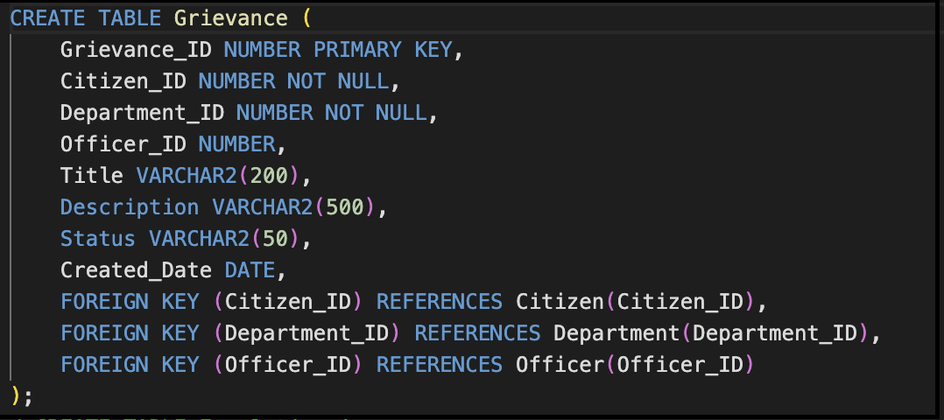

9.1.2 Data Manipulation Language (DML)
DML commands are used to insert and update data in the database.
- INSERT INTO statements are used to add records for citizens, grievances, departments, and officers.
- UPDATE statements modify grievance status during escalation.
- DELETE operations (if required) help manage obsolete data.
DML operations ensure that the database contains realistic and meaningful data for testing and analysis.
Eg) 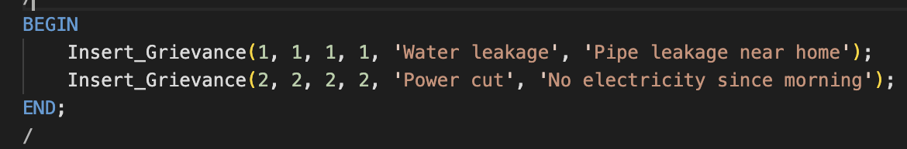

9.1.3 SELECT Queries
SELECT queries are used to retrieve and analyze data from the database.
The project implements:
- JOIN queries to combine data from multiple tables (e.g., citizen-wise grievance status).
- Aggregate functions such as COUNT to calculate department-wise grievance totals.
- GROUP BY clauses for summarized reports.
- LEFT JOIN with NULL checks to identify officers without assigned grievances.
These queries help in monitoring grievance flow and system performance.
Eg) 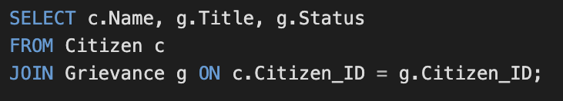

9.2 PL/SQL Components
PL/SQL is used to introduce automation and procedural logic into the database.

9.2.1 Stored Procedures
Stored procedures are created to encapsulate repetitive database operations.
- Procedures such as Insert_Grievance are used to insert grievance records in a structured manner.
- This improves code reusability and ensures controlled data insertion.
Eg) 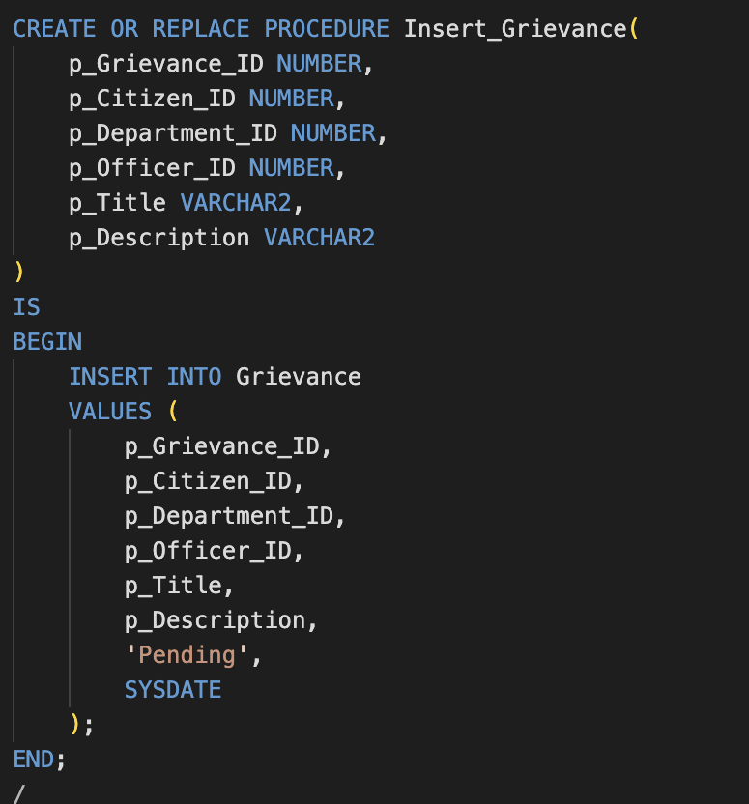

9.2.2 Triggers
Triggers are used to enforce business rules automatically.
- An AFTER UPDATE trigger is implemented to handle grievance escalation.
- When a grievance status changes to Escalated, a corresponding record is automatically inserted into the Escalation table.
Triggers ensure automatic enforcement of system logic without manual intervention.
Eg) 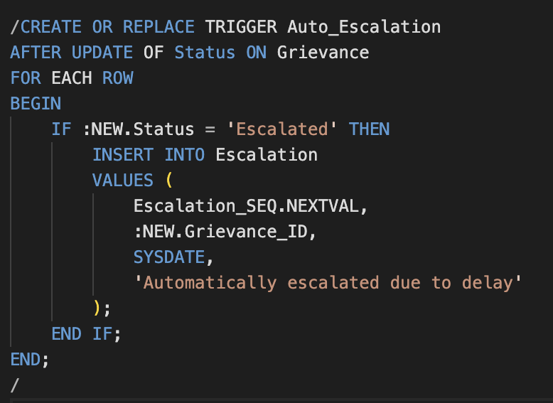

9.2.3 Cursors
Cursors are used (where applicable) to process multiple rows returned by a query.
- They allow row-by-row processing for reporting and validation tasks.
- Cursors improve control over data retrieval in PL/SQL blocks.

9.2.4 Exception Handling
Exception handling is included in PL/SQL programs to manage runtime errors.
- Exceptions help prevent abrupt termination of procedures.
- Meaningful error handling improves system reliability.

NOTE:-
The database implementation successfully converts the designed schema into a fully functional backend system. By using SQL for data definition and manipulation and PL/SQL for automation and control, the system ensures efficient grievance management, reliable escalation handling, and consistent data integrity.

10. TRANSACTION MANAGEMENT & CONCURRENCY
Transaction management is an important aspect of database systems that ensures data reliability, consistency, and correctness during database operations. In the Citizen Grievance Redressal & Escalation Management System, transaction management is used to safely handle grievance registration, status updates, escalations, and feedback storage.

10.1 Transaction Management
A transaction is a sequence of SQL operations that are executed as a single logical unit of work. In this project, transactions are used to ensure that database operations are either fully completed or safely rolled back in case of errors.

Use of Transactions in the Project
- When a grievance is registered, all related data is inserted in a controlled manner.
- When grievance status is updated (for example, from Pending to Escalated), the update and escalation entry are treated as a single transaction.
- Feedback insertion is committed only after successful grievance resolution.
The following SQL commands are used:
- COMMIT – permanently saves changes to the database.
- ROLLBACK – restores the database to the previous consistent state if an error occurs.
- SAVEPOINT – allows partial rollback within a transaction (used conceptually).
These commands help in maintaining data accuracy and system reliability.

10.2 ACID Properties
The database transactions in the system follow the ACID properties:
- Atomicity: Each transaction is completed fully or not executed at all. For example, grievance escalation is not partially recorded.
- Consistency: The database remains in a valid state before and after every transaction.
- Isolation: Multiple transactions can occur simultaneously without affecting each other.
- Durability: Once a transaction is committed, the data remains permanently stored even in case of system failure.
These properties ensure that grievance data remains safe and trustworthy.

10.3 Concurrency Control (Overview)
Concurrency control ensures that multiple users can access the database simultaneously without causing data inconsistency. In this project:
- Multiple citizens can register grievances at the same time.
- Officers can update grievance statuses concurrently.
- Read and write operations are handled safely by the DBMS.
The Oracle database internally manages concurrency using locking mechanisms, ensuring that one transaction does not interfere with another.
Although advanced concurrency techniques are handled by the DBMS automatically, the project design supports safe concurrent access by following proper transaction practices.
THUS,
Transaction management and concurrency control ensure that the Citizen Grievance Redressal & Escalation Management System operates reliably even under multiple simultaneous operations. By using transactions and relying on ACID principles, the system maintains data consistency, integrity, and correctness, making it suitable for real-world deployment.

11. TOOLS & TECHNOLOGIES USED
The successful implementation of the Citizen Grievance Redressal & Escalation Management System required the use of reliable database tools and technologies that support efficient backend development using SQL and PL/SQL.

11.1 Database Management System
- Oracle Database is used as the primary Database Management System.
- It provides strong support for relational database concepts, PL/SQL programming, and transaction management.
- Oracle ensures data integrity through constraints, triggers, and concurrency control mechanisms.

11.2 Programming Languages
- SQL (Structured Query Language) is used for:
  - Defining the database schema using DDL commands.
  - Manipulating data using DML commands.
  - Retrieving information using SELECT queries with joins and aggregate functions.
- PL/SQL (Procedural Language/SQL) is used for:
  - Writing stored procedures and functions.
  - Implementing triggers for automatic escalation.
  - Handling cursors and exception management.

11.3 Development and Execution Tools
- Oracle Live SQL is used to:
  - Write, execute, and test SQL and PL/SQL code online.
  - View query results and execution status.
  - Capture output screenshots for result documentation.
- Oracle SQL Developer (optional) can be used as an offline development environment for writing and testing database programs.
THUS,
The combination of Oracle Database, SQL, and PL/SQL provides a powerful and reliable backend platform for implementing the Citizen Grievance Redressal & Escalation Management System. These tools ensure efficient data handling, automation, and maintainability of the database system.

12. EXPECTED OUTCOMES
The successful implementation of the Citizen Grievance Redressal & Escalation Management System is expected to deliver an efficient and reliable backend database solution for managing citizen grievances. The key outcomes of the project are as follows:
- Successful creation of a normalized relational database that stores grievance-related data in a structured and organized manner.
- Efficient data storage and retrieval using optimized SQL queries involving joins, aggregate functions, and grouping.
- Automation of critical backend operations such as grievance insertion and escalation using PL/SQL procedures and triggers.
- Improved data consistency and integrity through the use of primary keys, foreign keys, constraints, and transaction management.
- Reduced manual effort and errors by replacing traditional file-based grievance handling with a centralized database system.
- Scalable and maintainable database design that can accommodate future growth in grievances, departments, and users.

RESULT:-
/*CREATE TABLE Citizen (
Citizen_ID NUMBER PRIMARY KEY,
Name VARCHAR2(100) NOT NULL,
Email VARCHAR2(100) UNIQUE NOT NULL,
Phone VARCHAR2(20),
Address VARCHAR2(255)
);
CREATE TABLE Department (
Department_ID NUMBER PRIMARY KEY,
Department_Name VARCHAR2(100) NOT NULL
);*/
/*CREATE TABLE Officer (
Officer_ID NUMBER PRIMARY KEY,
Name_O VARCHAR2(100) NOT NULL,
Email_O VARCHAR2(100) UNIQUE NOT NULL,
Department_ID NUMBER NOT NULL,
FOREIGN KEY (Department_ID) REFERENCES Department(Department_ID)
);*/
/*CREATE TABLE Grievance (
Grievance_ID NUMBER PRIMARY KEY,
Citizen_ID NUMBER NOT NULL,
Department_ID NUMBER NOT NULL,
Officer_ID NUMBER,
Title VARCHAR2(200),
Description VARCHAR2(500),
Status VARCHAR2(50),
Created_Date DATE,
FOREIGN KEY (Citizen_ID) REFERENCES Citizen(Citizen_ID),
FOREIGN KEY (Department_ID) REFERENCES Department(Department_ID),
FOREIGN KEY (Officer_ID) REFERENCES Officer(Officer_ID)
);*/
/*CREATE TABLE Escalation (
Escalation_ID NUMBER PRIMARY KEY,
Grievance_ID NUMBER NOT NULL,
Escalation_Date DATE,
Reason VARCHAR2(300),
FOREIGN KEY (Grievance_ID) REFERENCES Grievance(Grievance_ID)
);*/
/*CREATE TABLE Feedback (
Feedback_ID NUMBER PRIMARY KEY,
Grievance_ID NUMBER UNIQUE NOT NULL,
Rating NUMBER CHECK (Rating BETWEEN 1 AND 5),
Comments VARCHAR2(300),
FOREIGN KEY (Grievance_ID) REFERENCES Grievance(Grievance_ID)
);*/
/*CREATE SEQUENCE Escalation_SEQ
START WITH 1
INCREMENT BY 1;*/
/*CREATE OR REPLACE PROCEDURE Insert_Citizen(
p_Citizen_ID NUMBER,
p_Name VARCHAR2,
p_Email VARCHAR2,
p_Phone VARCHAR2,
p_Address VARCHAR2
)
IS
BEGIN
INSERT INTO Citizen
VALUES (p_Citizen_ID, p_Name, p_Email, p_Phone, p_Address);
END;
/*/
/*CREATE OR REPLACE PROCEDURE Insert_Department(
p_Department_ID NUMBER,
p_Department_Name VARCHAR2
)
IS
BEGIN
INSERT INTO Department
VALUES (p_Department_ID, p_Department_Name);
END;
/*/
/*CREATE OR REPLACE PROCEDURE Insert_Officer(
p_Officer_ID NUMBER,
p_Name VARCHAR2,
p_Email VARCHAR2,
p_Department_ID NUMBER
)
IS
BEGIN
INSERT INTO Officer
VALUES (p_Officer_ID, p_Name, p_Email, p_Department_ID);
END;
/*/
/*CREATE OR REPLACE PROCEDURE Insert_Grievance(
p_Grievance_ID NUMBER,
p_Citizen_ID NUMBER,
p_Department_ID NUMBER,
p_Officer_ID NUMBER,
p_Title VARCHAR2,
p_Description VARCHAR2
)
IS
BEGIN
INSERT INTO Grievance
VALUES (
p_Grievance_ID,
p_Citizen_ID,
p_Department_ID,
p_Officer_ID,
p_Title,
p_Description,
'Pending',
SYSDATE
);
END;
/*/
/*CREATE OR REPLACE TRIGGER Auto_Escalation
AFTER UPDATE OF Status ON Grievance
FOR EACH ROW
BEGIN
IF :NEW.Status = 'Escalated' THEN
INSERT INTO Escalation
VALUES (
Escalation_SEQ.NEXTVAL,
:NEW.Grievance_ID,
SYSDATE,
'Automatically escalated due to delay'
);
END IF;
END;
/*/
/*CREATE OR REPLACE TRIGGER Check_Feedback
BEFORE INSERT ON Feedback
FOR EACH ROW
DECLARE
v_status VARCHAR2(50);
BEGIN
SELECT Status INTO v_status
FROM Grievance
WHERE Grievance_ID = :NEW.Grievance_ID;

IF v_status <> 'Resolved' THEN
RAISE_APPLICATION_ERROR(-20001,
'Feedback allowed only after grievance resolution');
END IF;
END;
/*/
-- BEGIN
-- Insert_Department(1, 'Water Supply');
-- Insert_Department(2, 'Electricity');
-- END;
-- /
-- BEGIN
-- Insert_Officer(1, 'Mr. Sharma', 'sharma@gov.in', 1);
-- Insert_Officer(2, 'Ms. Verma', 'verma@gov.in', 2);
-- END;
-- /

-- BEGIN
-- Insert_Citizen(1, 'Aman', 'aman@gmail.com', '9876543210', 'Delhi');
-- Insert_Citizen(2, 'Riya', 'riya@gmail.com', '9123456789', 'Mumbai');
-- END;
-- /

-- BEGIN
-- Insert_Grievance(1, 1, 1, 1, 'Water leakage', 'Pipe leakage near home');
-- Insert_Grievance(2, 2, 2, 2, 'Power cut', 'No electricity since morning');
-- END;
-- /
-- UPDATE Grievance
-- SET Status = 'Escalated'
-- WHERE Grievance_ID = 1;
-- SELECT * FROM Escalation;
-- SELECT c.Name, g.Title, g.Status
-- FROM Citizen c
-- JOIN Grievance g ON c.Citizen_ID = g.Citizen_ID;
-- SELECT d.Department_Name, COUNT(g.Grievance_ID) AS Total_Grievances
-- FROM Department d
-- LEFT JOIN Grievance g ON d.Department_ID = g.Department_ID
-- GROUP BY d.Department_Name;
-- SELECT o.Name_O
-- FROM Officer o
-- LEFT JOIN Grievance g ON o.Officer_ID = g.Officer_ID
-- WHERE g.Grievance_ID IS NULL;

-- SELECT c.Name, g.Grievance_ID, g.Title, g.Status
-- FROM Citizen c
-- JOIN Grievance g ON c.Citizen_ID = g.Citizen_ID;

-- SELECT d.Department_Name, COUNT(g.Grievance_ID) AS Total_Grievances
-- FROM Department d
-- LEFT JOIN Grievance g ON d.Department_ID = g.Department_ID
-- GROUP BY d.Department_Name;

-- SELECT g.Grievance_ID, e.Escalation_Date, e.Reason
-- FROM Grievance g
-- JOIN Escalation e ON g.Grievance_ID = e.Grievance_ID;

-- SELECT o.Officer_ID, o.Name_O
-- FROM Officer o
-- LEFT JOIN Grievance g ON o.Officer_ID = g.Officer_ID
-- WHERE g.Grievance_ID IS NULL;

-- SELECT g.Grievance_ID, f.Rating, f.Comments
-- FROM Grievance g
-- JOIN Feedback f ON g.Grievance_ID = f.Grievance_ID;

CONCLUSION
The development of the Citizen Grievance Redressal & Escalation Management System represents a significant advancement in the way public service organizations manage and resolve citizen complaints. Through the careful application of relational database design principles, normalization, and backend automation, this project has successfully created a centralized, efficient, and scalable database system capable of handling grievance-related operations effectively.
By integrating key entities such as citizens, grievances, departments, officers, escalations, and feedback into a unified relational database, the system eliminates the inefficiencies, delays, and data inconsistencies associated with traditional manual or file-based grievance handling mechanisms. The use of well-structured tables, primary and foreign keys, and a normalized schema (up to 3NF) ensures high levels of data integrity, consistency, and minimal redundancy.
The implementation of the backend using SQL and PL/SQL further strengthens the system by enabling structured data manipulation, efficient querying, and automation of critical operations such as grievance insertion and escalation handling through procedures and triggers. Transaction management and constraints ensure that the system remains reliable and maintains data correctness even during concurrent operations.
The modular and scalable design of the database allows the system to adapt easily to future requirements, such as the addition of new departments, officers, or grievance categories. Overall, this project demonstrates the effective use of DBMS concepts to solve a real-world administrative problem, highlighting the importance of backend database systems in improving transparency, accountability, and efficiency in grievance redressal processes.

